Below are a couple of images taken from the output of the VNA that demonstrate the frequency response of the 3rd generation filter that we are designing for practicum this fall. In the first image, the response of the filter is shown with the pass band indicated by markers 1 and 2. Marker 3 is the intended signal of the filter - 436.5 MHz. Here, the desired frequency is slightly outside of the pass band.

Image 1. 3rd Rev pass band response without modification

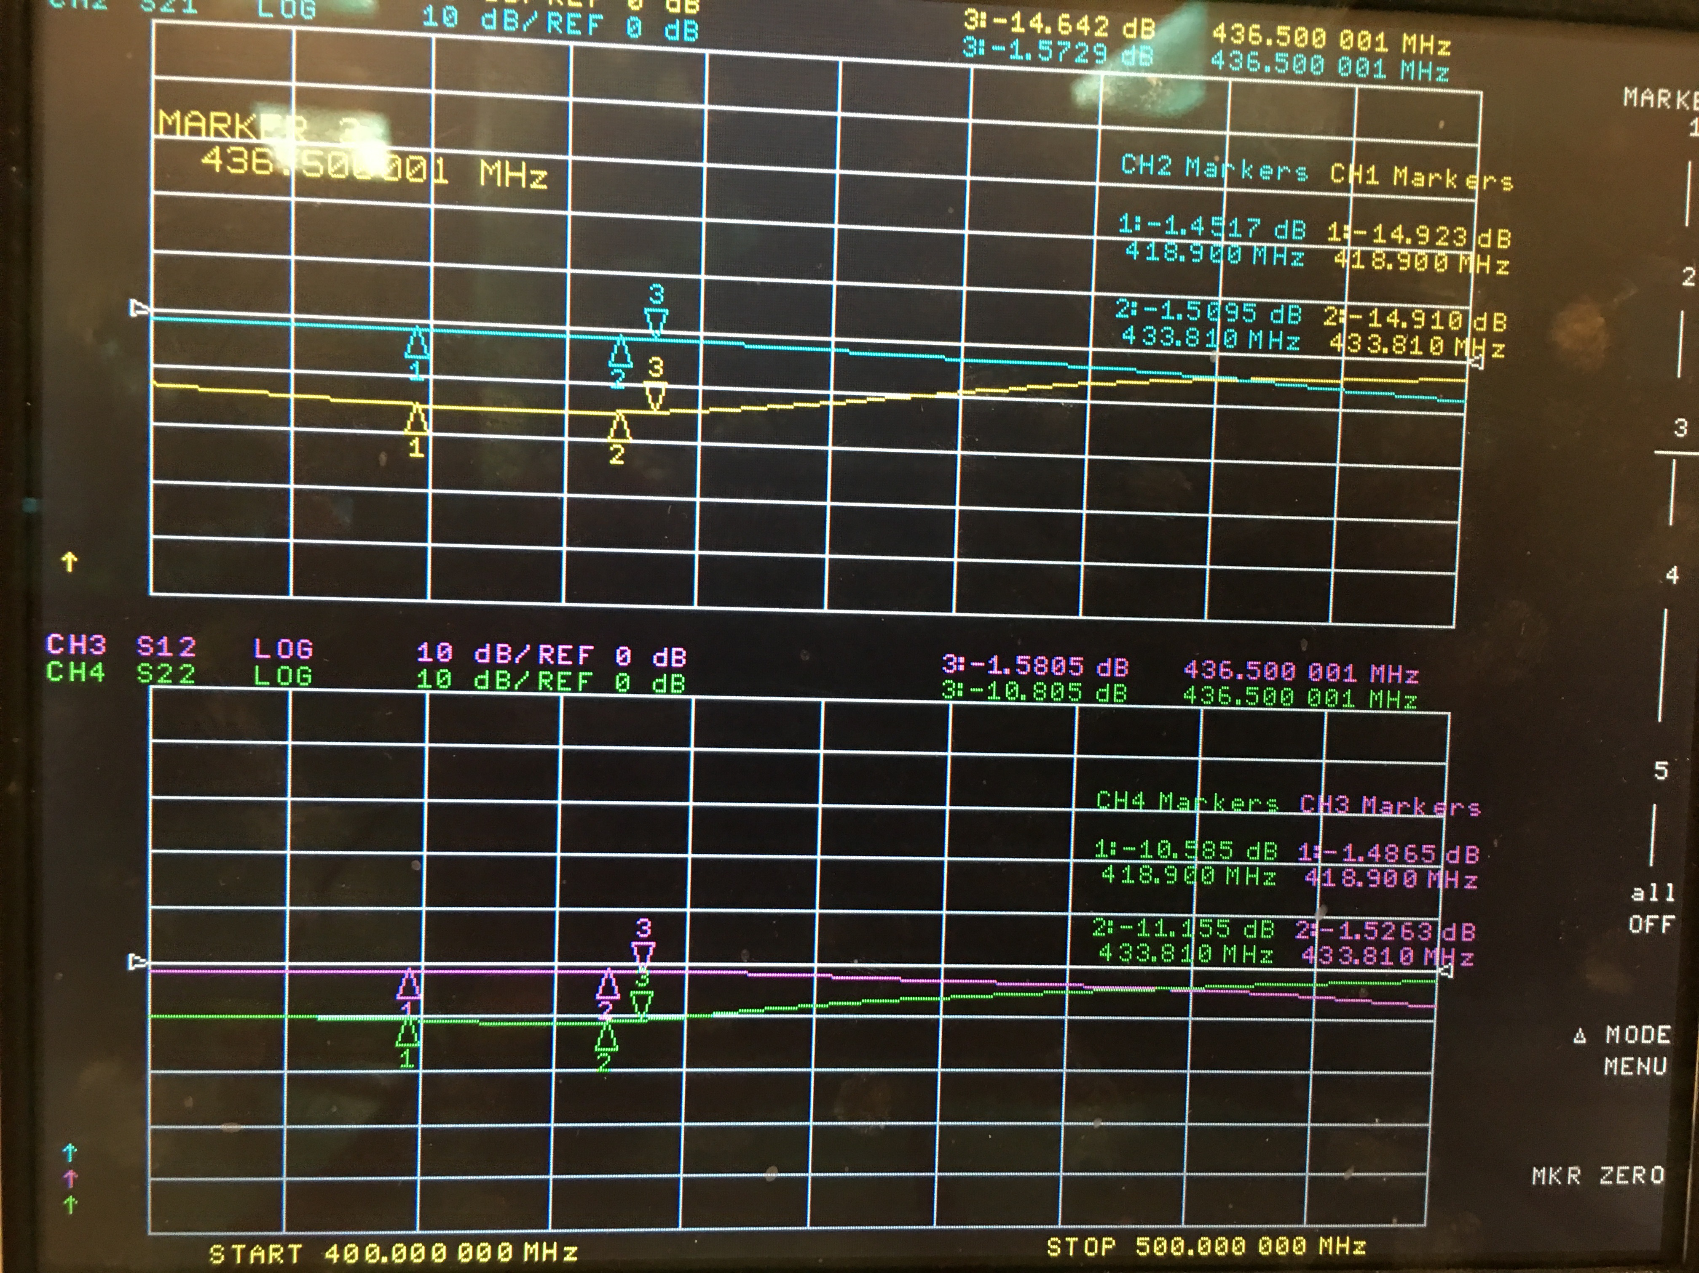

In the image below, marker 3 shows the intended location of the 2nd harmonic of our 436.5 MHz signal. Here, the measured frequency is 647.41 MHz, which is well below the desire frequency of 873 MHz. Idealy, the 2nd harmonic will fall into the “dip” seen in the image. This is an intended result of the elliptical filter.

Image 2. 3rd Rev 2nd harmonic response without modification

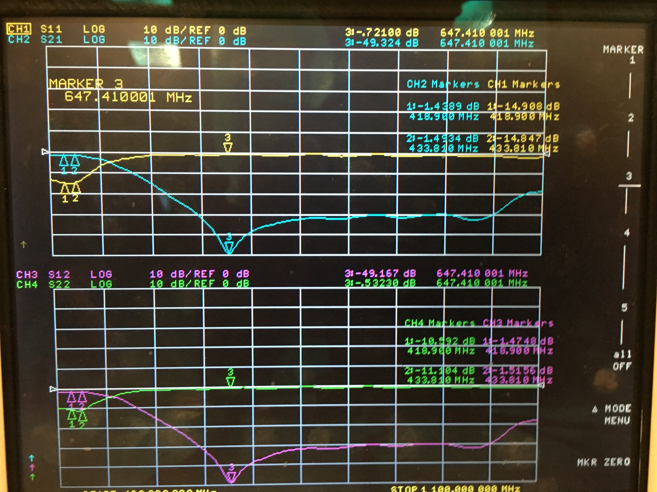

In the next several images I intend to demonstarate how making a few modifications to the filter board improves the response of the filter. These modifications were carried out in two steps and each step will be analyzed individualy. Of note, no actual components were changed during these modifications.

First, I added copper tape to both the top and bottom edges of the board. I also soldered the SMA connectors to the ground plane on the bottom of the board. This, in essence, connects the lower and upper ground planes. In the image below, we see that after the modification was performed, the center frequency in the “dip” of the filter has increased by about 50 MHz. Also, the attenuation has increased from -49dB to -57dB at this frequency.

Image 3. 3rd Rev 2nd harmonic response with first modification

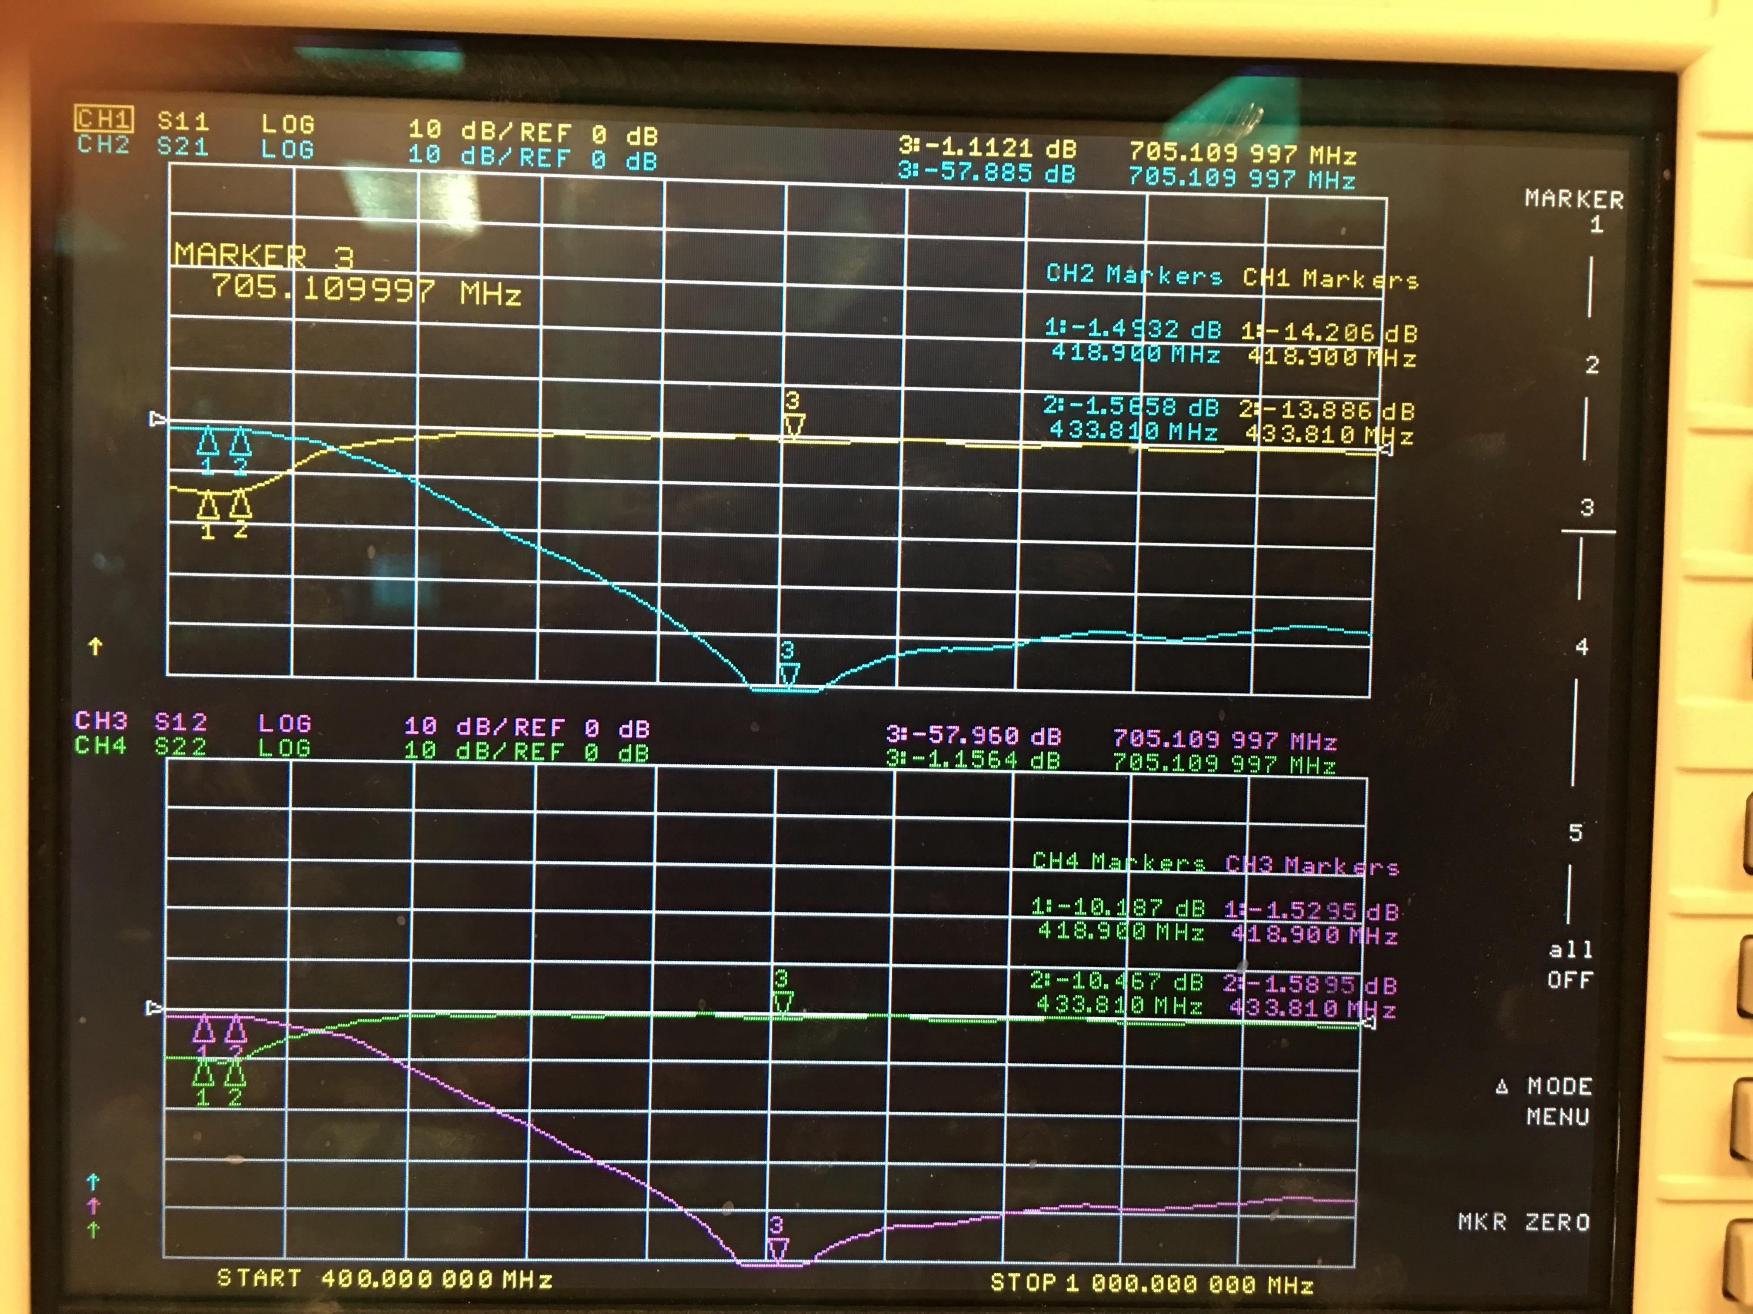

Below, the 2nd harmonic of our signal is only -37dB down (we desire -40dB or greater).

Image 4. 3rd Rev 2nd harmonic response with first modification

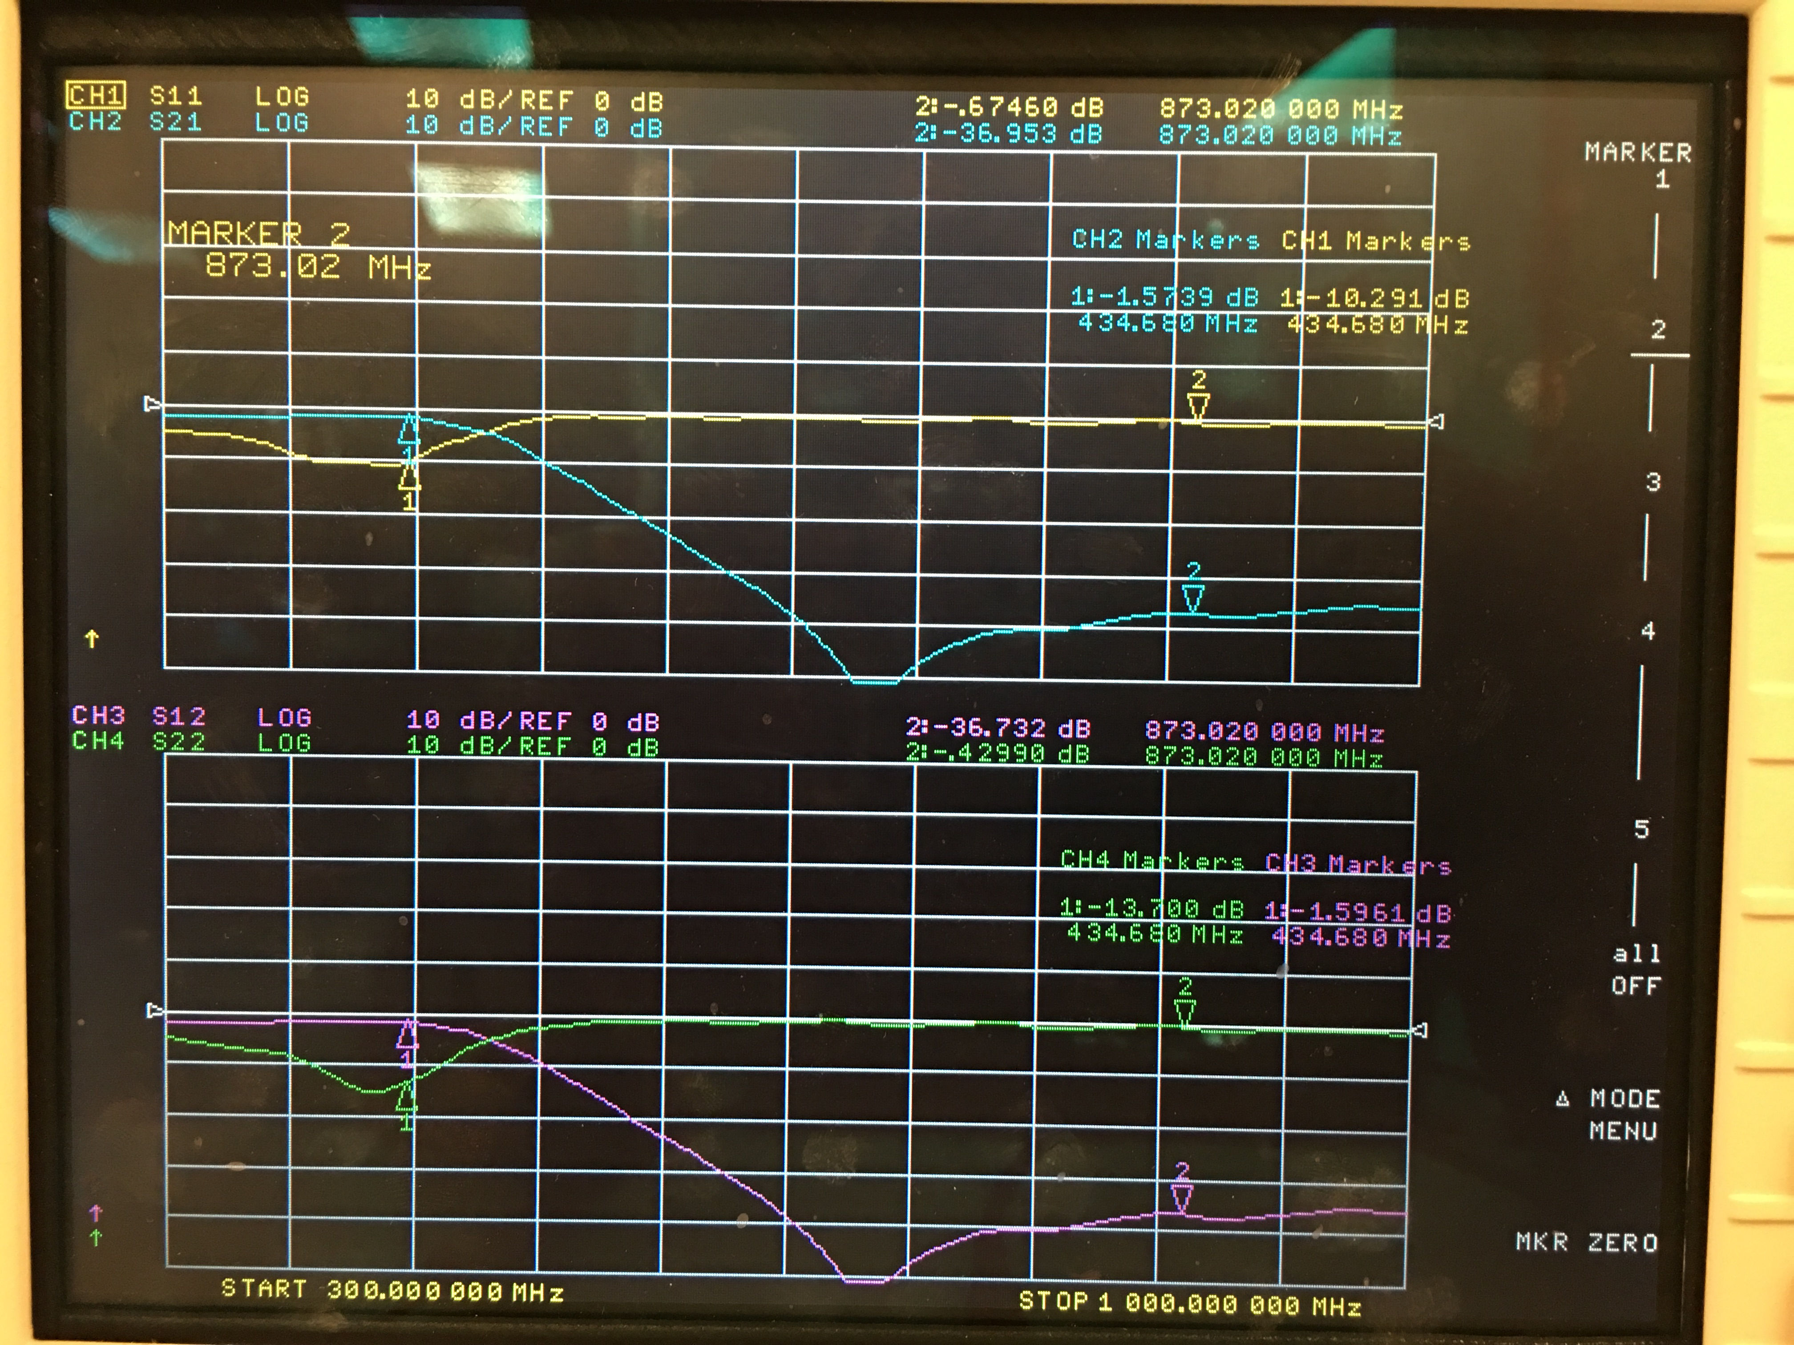

The final modification to the filter included drilling vias through the board to connect the bottom and top ground planes at specific points on the board. Most of the vias were placed next to the grounded side of components. Wire was used through the vias to connect the top and bottom layers by soldering the wire to either side.

The pass band of the fitler is shown below. Here our signal is inside the bass band, but it is still to the far right.

Image 5. 3rd Rev pass band response with final modification

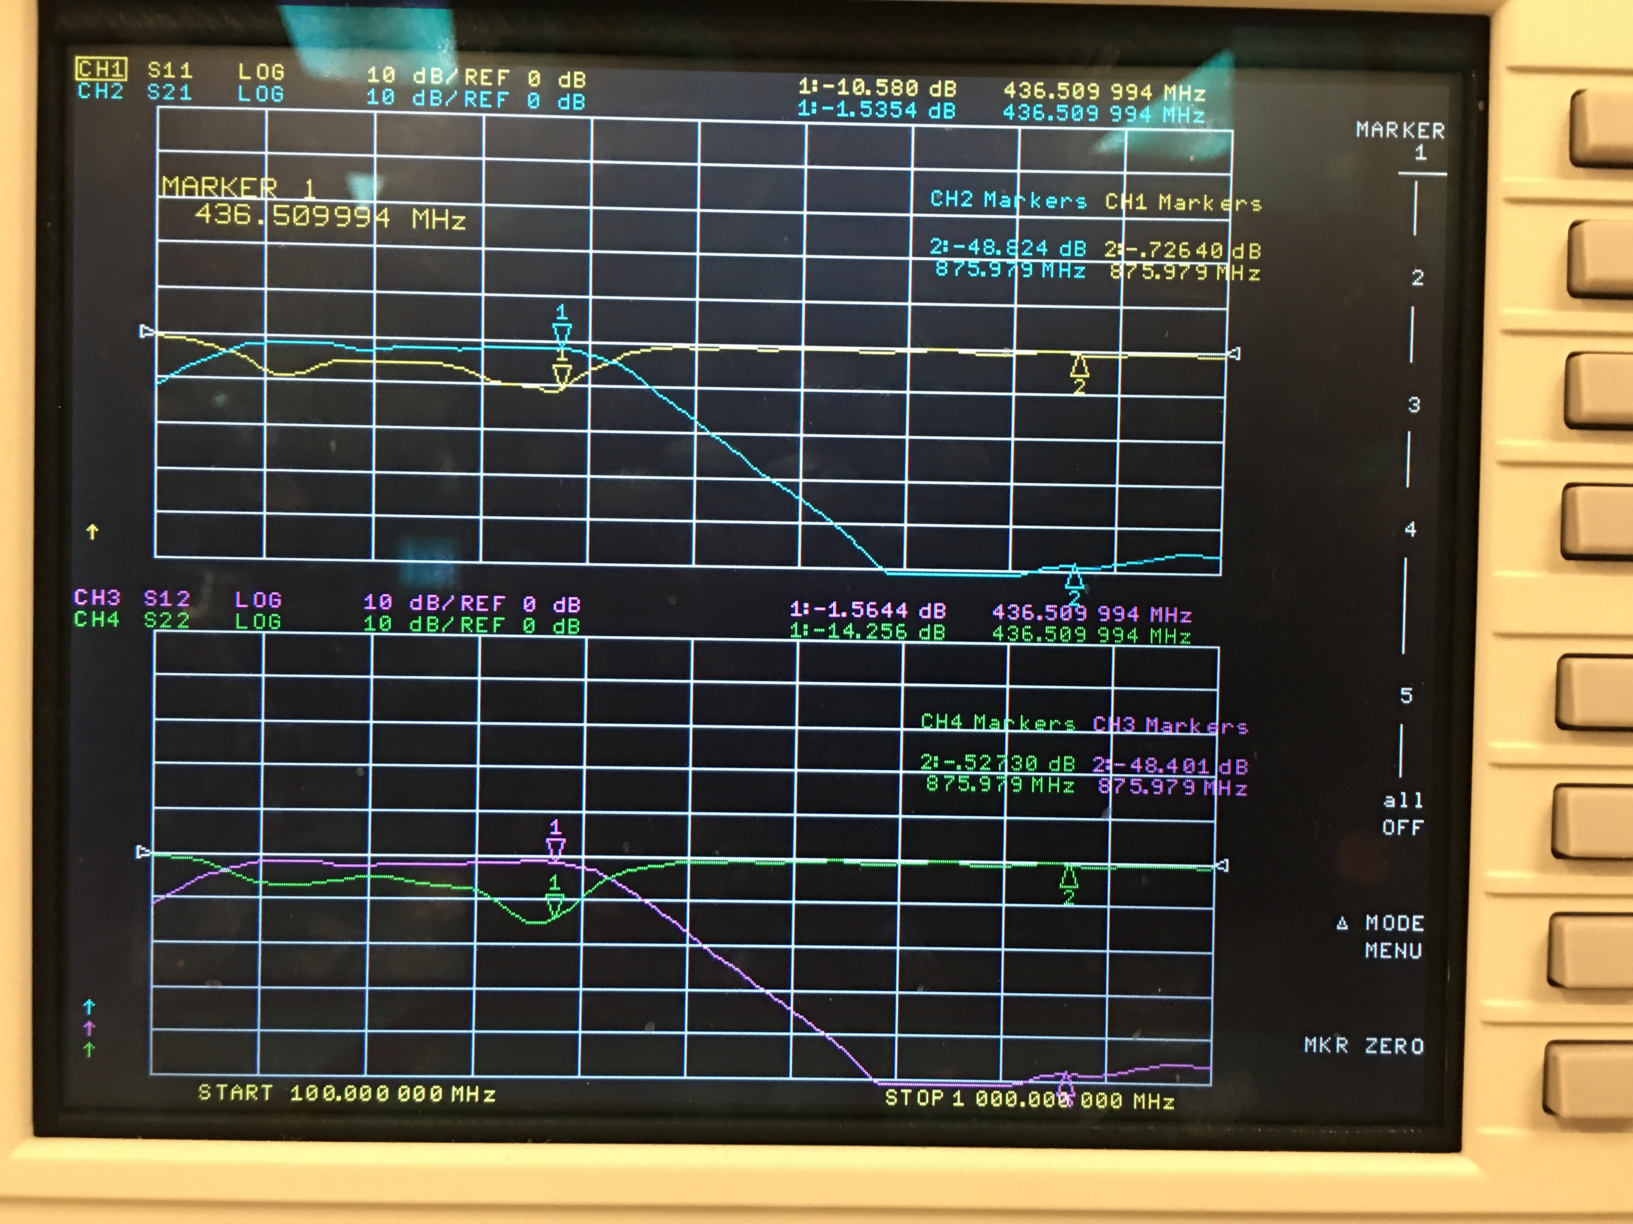

A close-up image of the pass band of the filter is shown below.

Image 6. 3rd Rev pass band response (close-up) with final modification

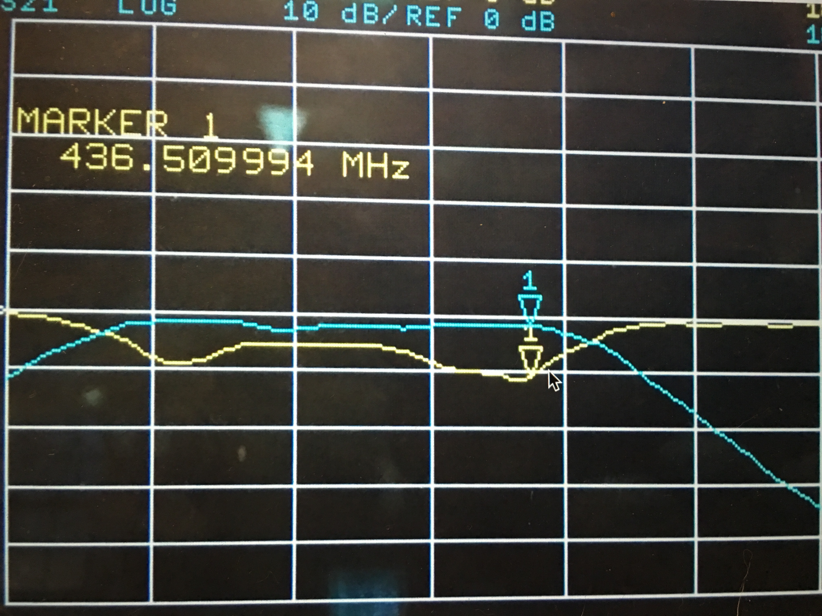

The next image shows the attenuation of the 2nd harmonic of our 436.5 MHz signal. Here, we see that the 2nd harmonic isnow attenuated -48.8dB (it was -37dB before). Remember, we need at least -40dB attenuation of the second harmonic, so this will now meet specifictaion.

Image 7. 3rd Rev 2nd harmonic response (close-up) with final modification

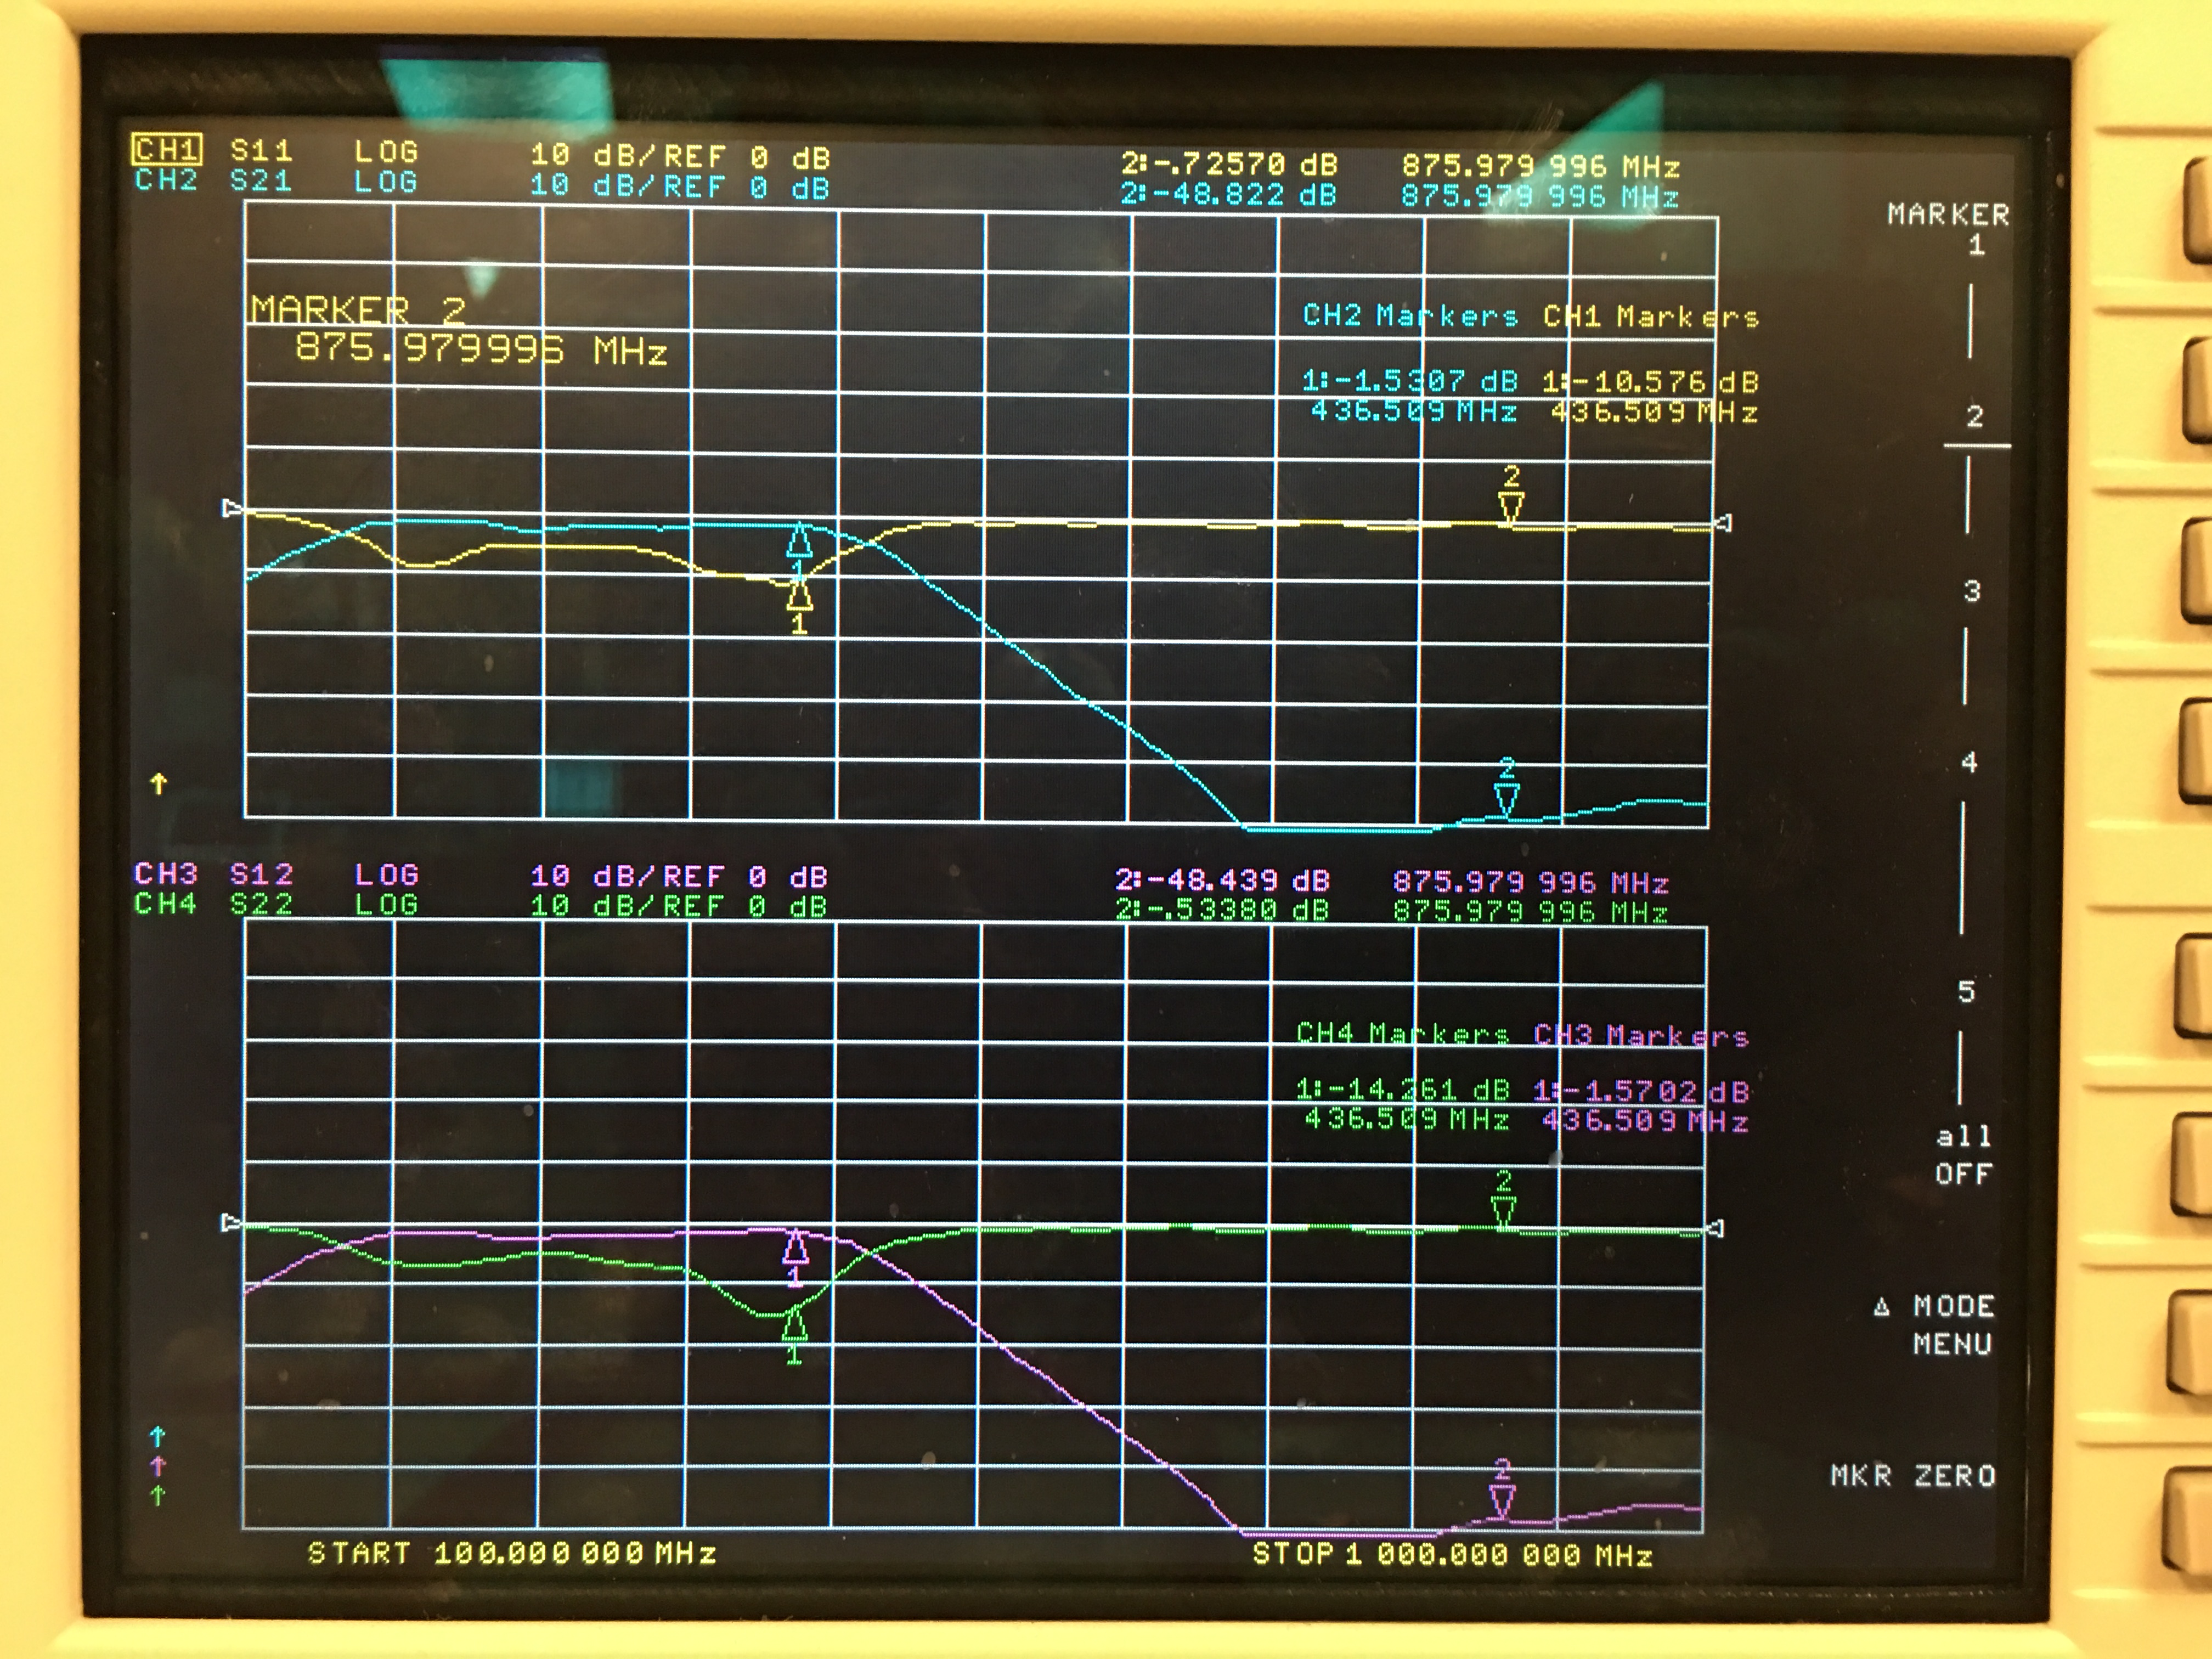

For comarison, the LTSpice simulation of this filter is shown below. It is interesting that the overall response is very simular between both the simulated filter and the built filter. The main difference is where the pass band of the two fall. The built filter is shifted down by about 50 MHz.

Image 8. LTSpice plot of filter

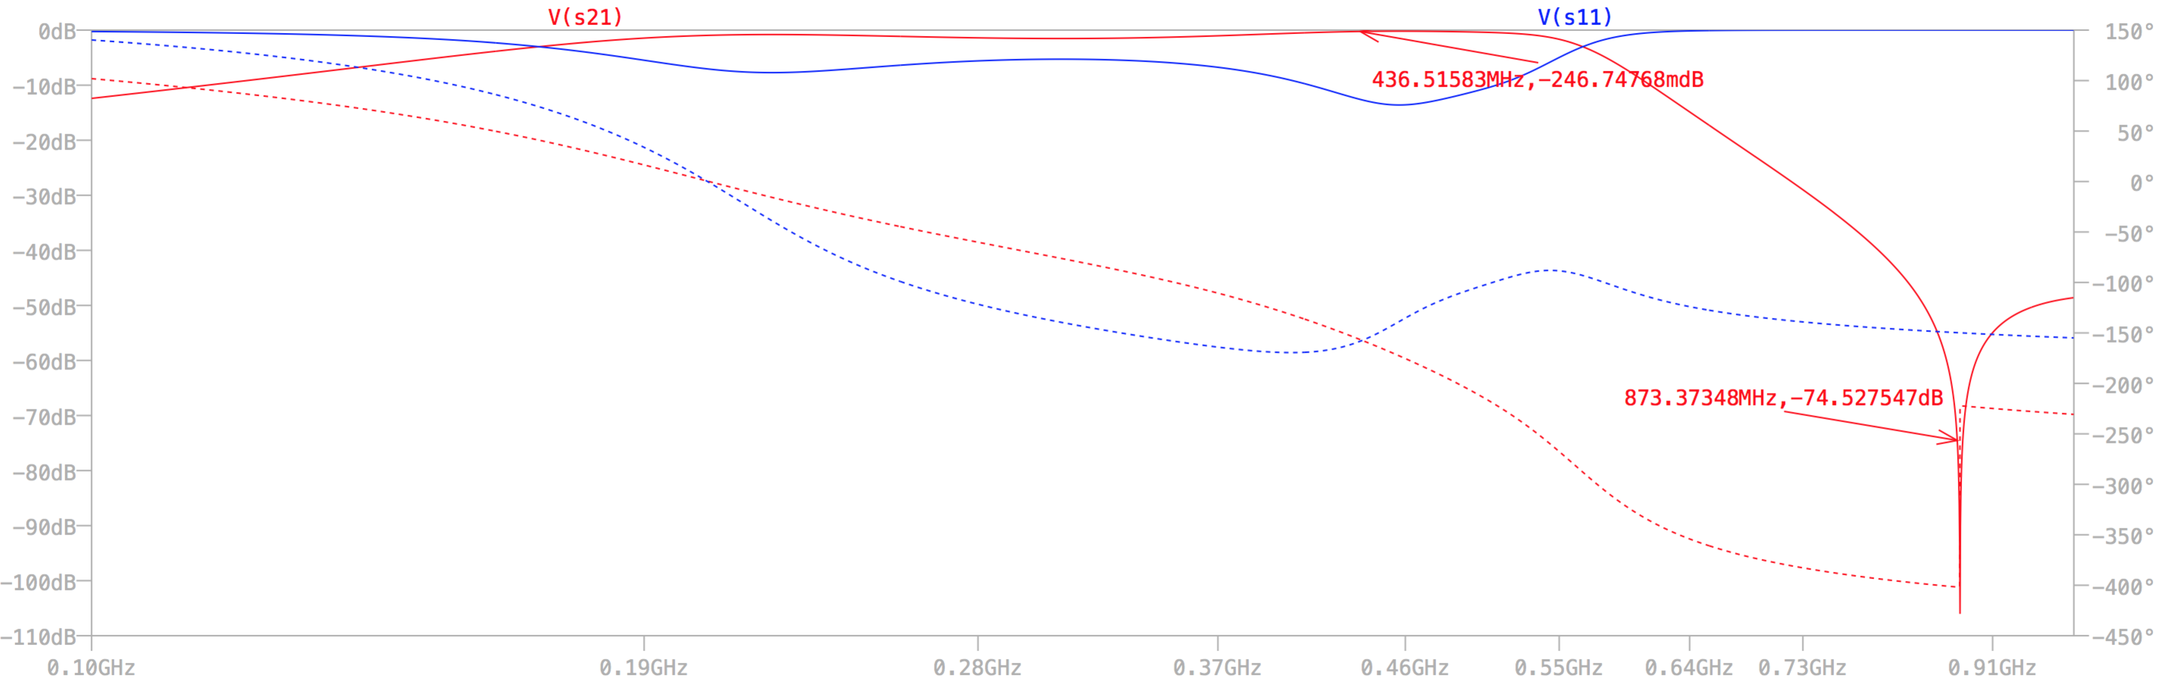

Image 9. LTSpice schematic of filter with s11 and s21

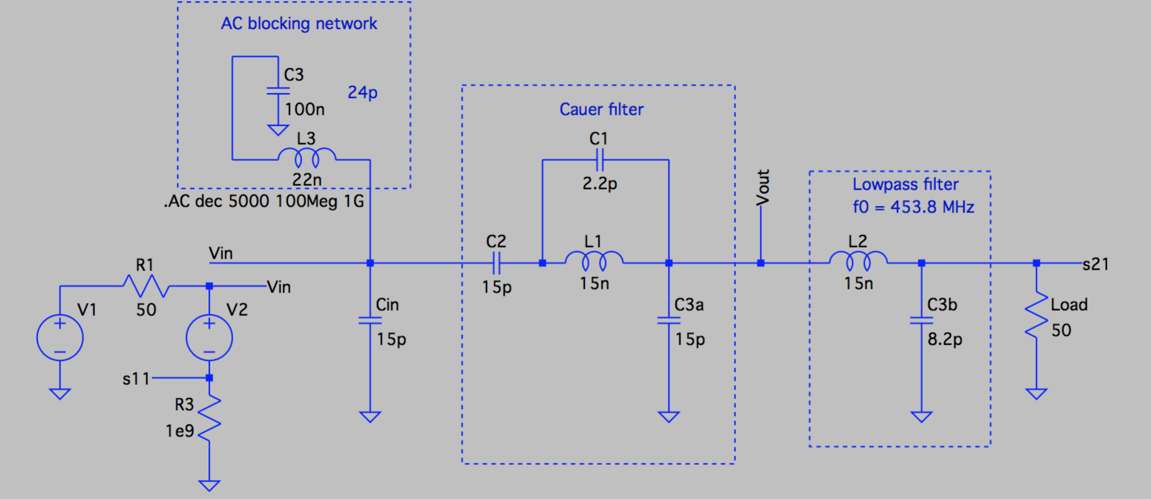

Below is an image of the filter board after the vias were drilled. Note: for future designs, the vias will be incorporated into the design and fabricated by the router. Notice how most of the vias are plased next to grounded components. One via is foating in the ground plane. This process is loosly called “stapling”. I suggest using this technique to form a line of vias on the board where the copper tape is not feasable. In escence, we will create a box around the RF waveguides to connect the ground plane on the bottom layer to the ground plane on the top layer.

Image 10. 3rd Rev board with via drillings

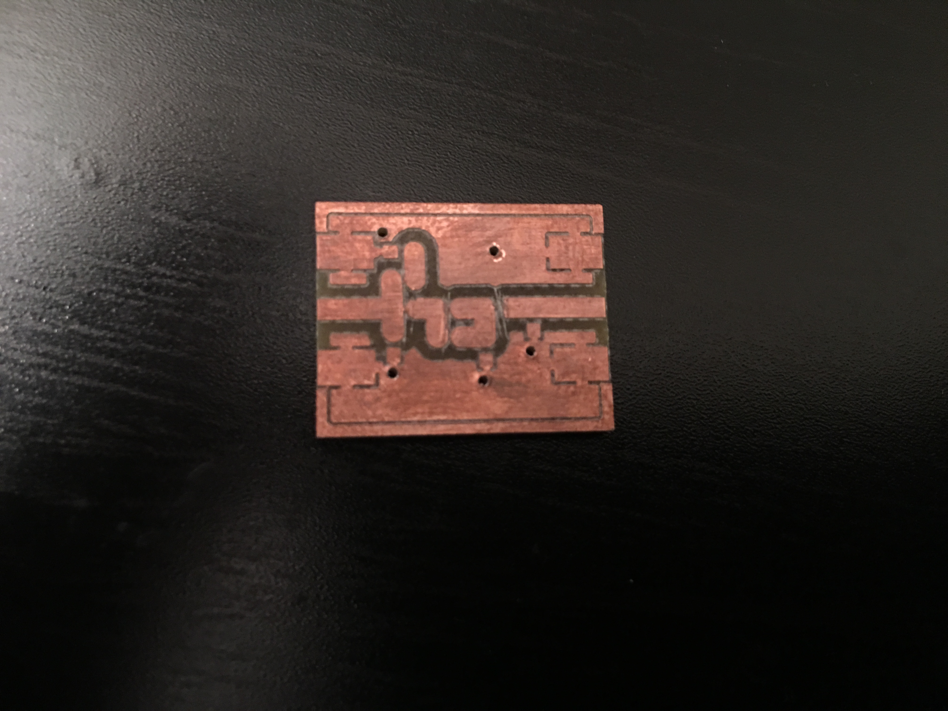

The image below shows the final design of this (3rd Rev) filter. The copper tape can be seen on the top and bottom of the board. Also, the solder joints are obvious where the vias were made and completed using wire.

Image 11. 3rd Rev board complete

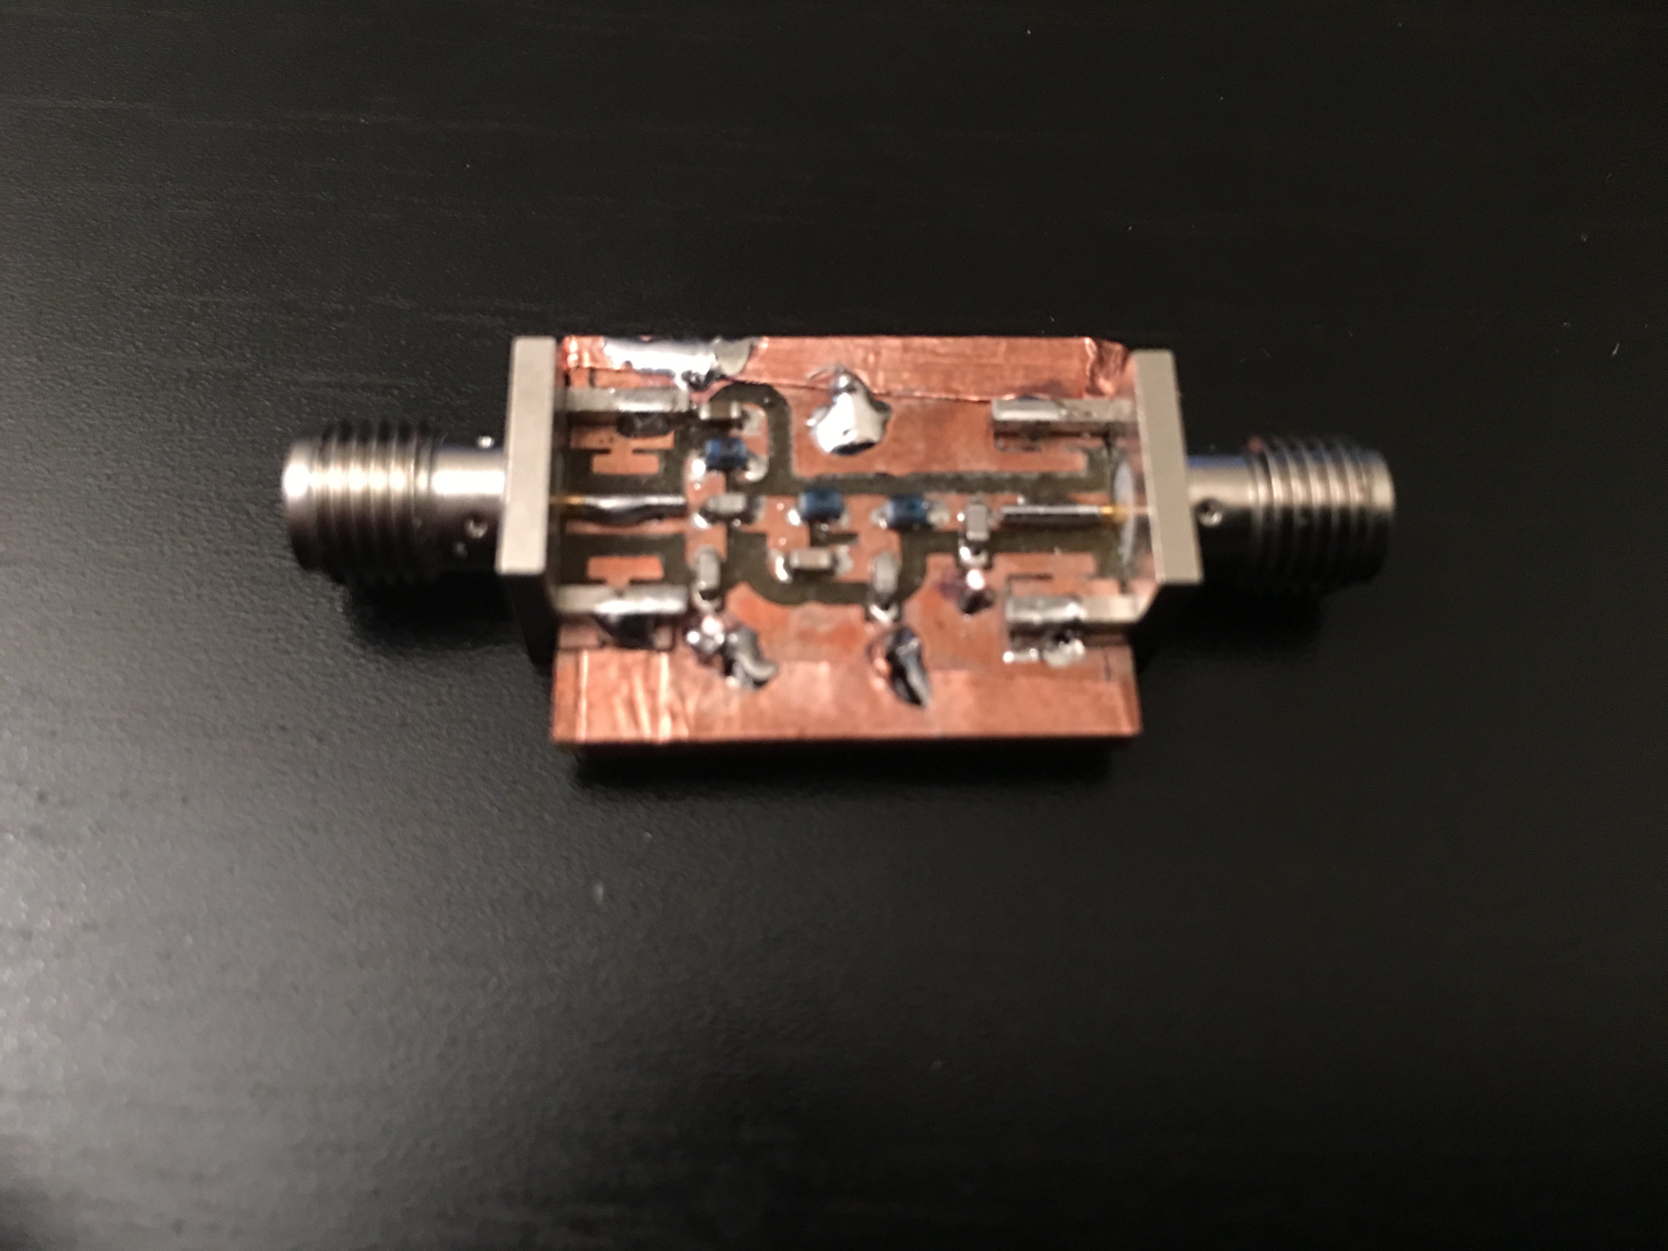

For comparison, the 1st, 2nd, and 3rd versions of the filters are shown below. We were able to shrink the board down in size by moving components closer together in each version. Also, we added an AC blocking network to the final design so it actually has more components than the previous two.

Image 12. 1st, 2nd, and 3rd Revs of the filter layout

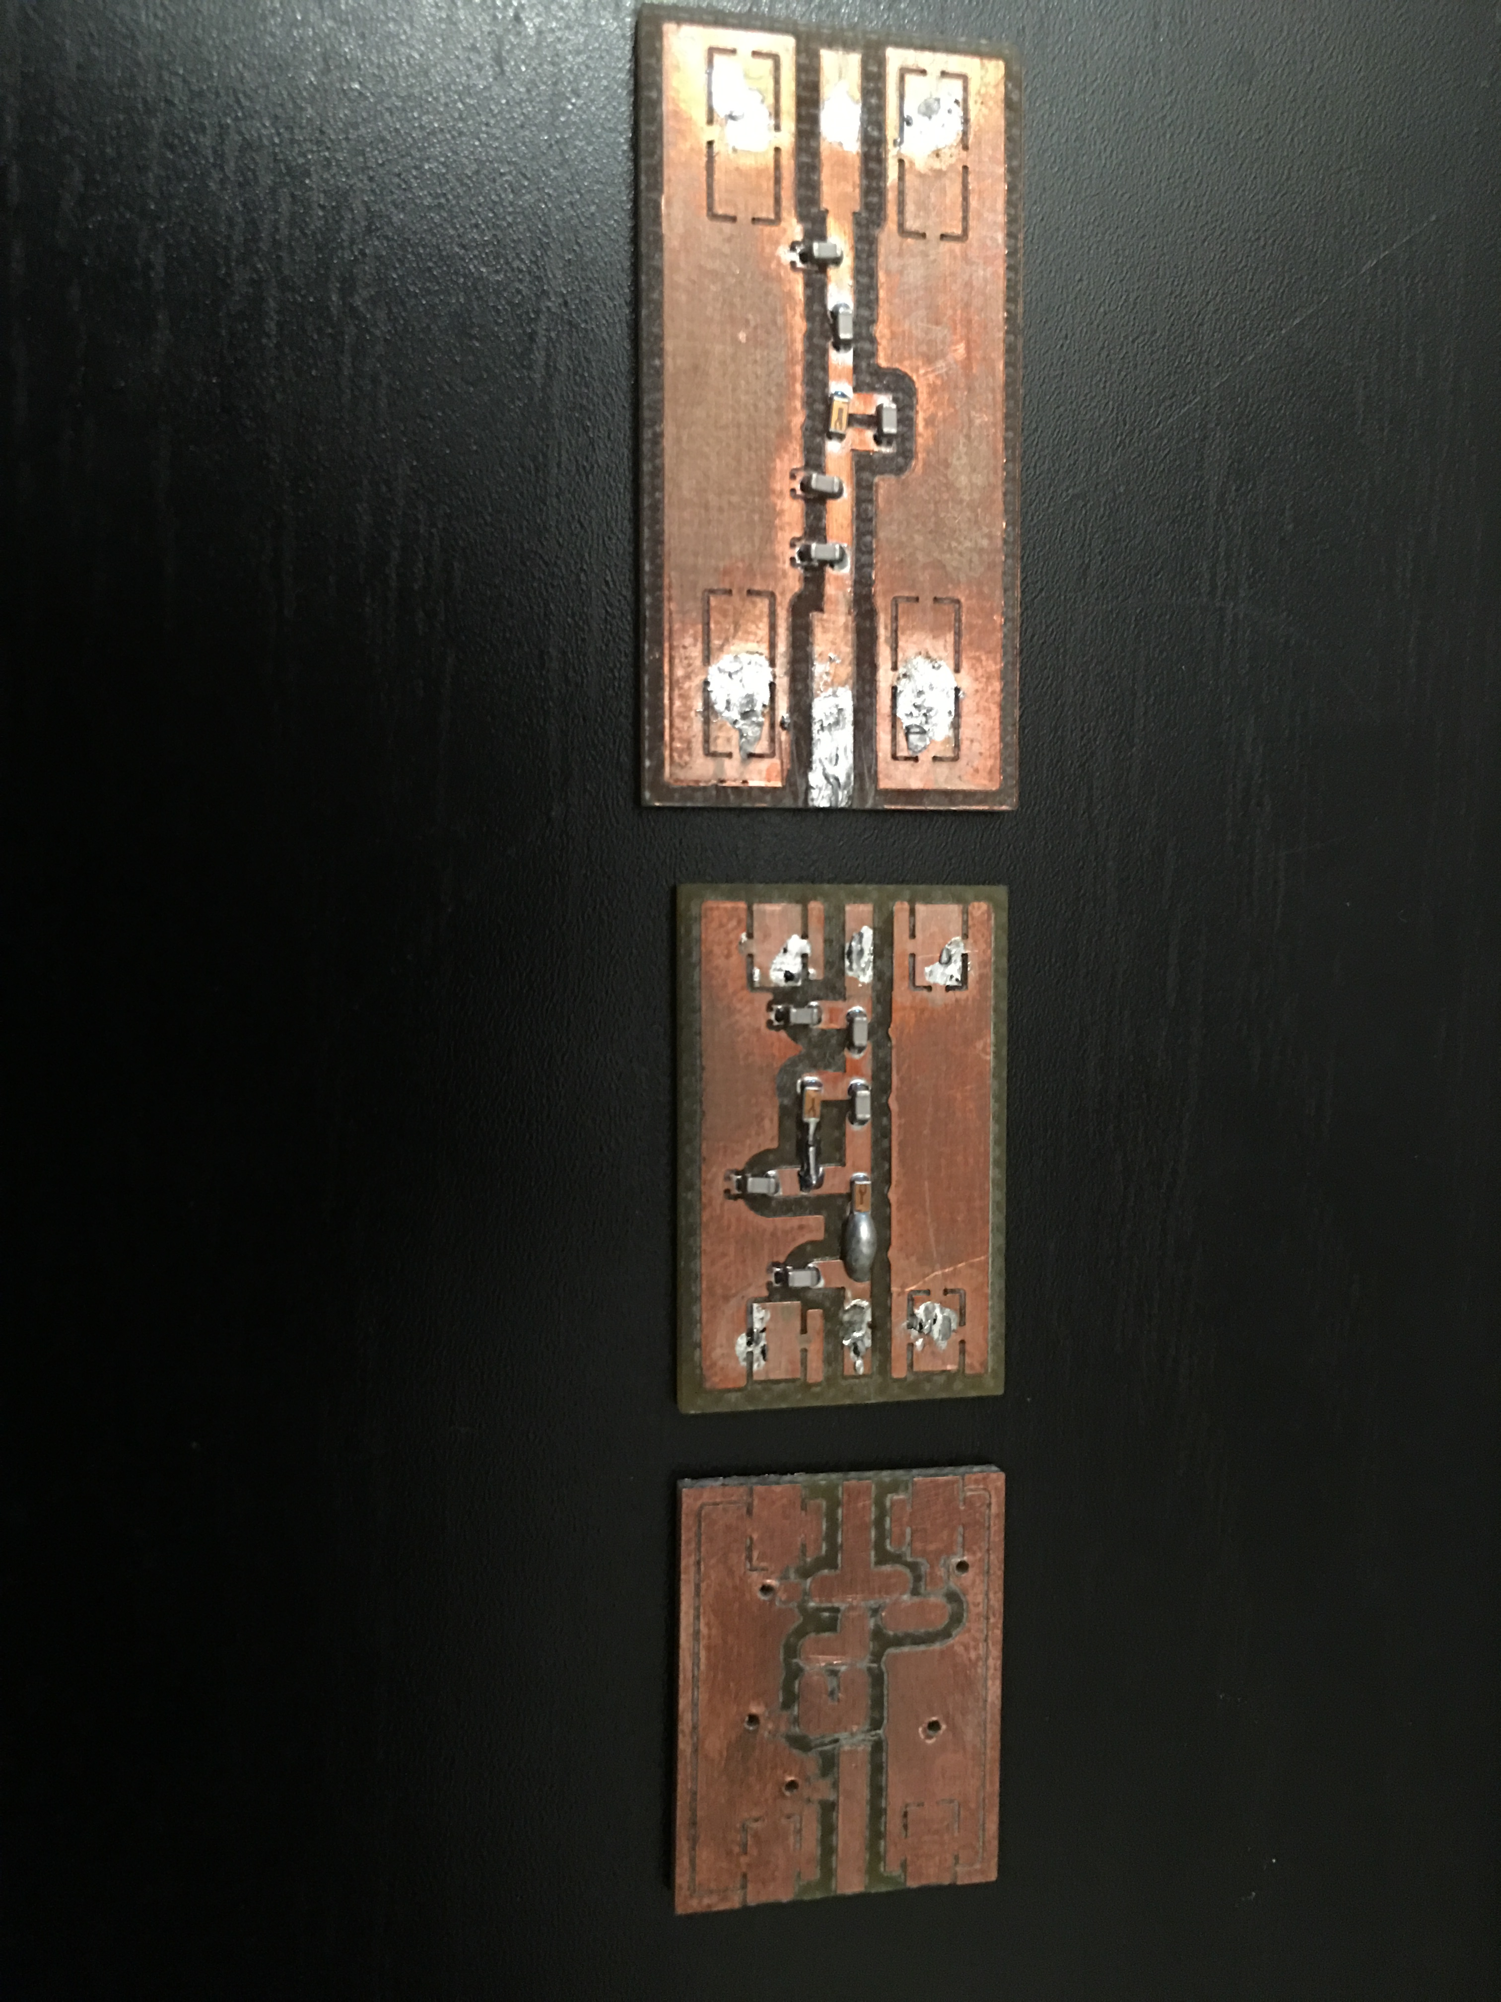

Notes:

This filter is far from perfect, but should be fine to use for practicum

* s11 needs some work. Currently we are passing about 60% - 70% of the signal at 436.5 MHz
* We need to determine the bandwidth of the signal that we are going to use for the CubeSat so that we can adjust the pass band of the filter accordingly.

We could consider using tuneable capacitors to dial in the response of the next generation of this filter. I think we can choose 2 or 3 caps that will be significant enough in the response to make them tuneable. We can either tune them and leave them on the board or carefully desolder them and determine their actual capacitance by testing them at the signal frequency.